FMS Flight Simulator Instructions
System requirements: above windows 98
Flight simulation system includes: one CD-Rom, one USB cable and one operation manual.
Notice: It is best to close the other programs before you play the FMS flight simulator
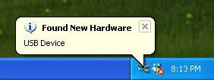
1. Insert the CD-Rom. Turn on the radio, and connect the
transmitter and the computer with the USB cable, the you
will find a new icon appeared at the bottom to the right
corner.

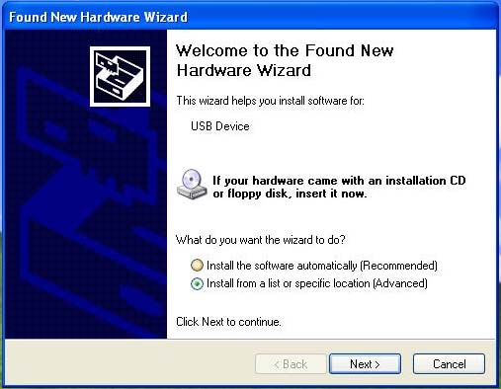
2.Some time later (it depends on
computer’s speed) you will see a
window about how to install the
program of the USB devise. Choose the
“Install the software automatically
(Recommended)”,then click “Next>”,
now go to 5.
If this does not work, Choose the
“Install form a list or specific location
(Advanced)”, and follow steps3 and 4.

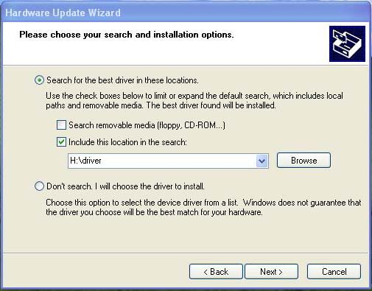
3. Choose the “Include this location in the
search”, then click the “Browse”.

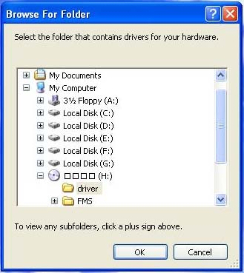
4. Choose “driver” in which you had placed the
CD (most likely in disk D or E in the example
shown here it is H). Click “OK” to exit. Then
click the “next”.

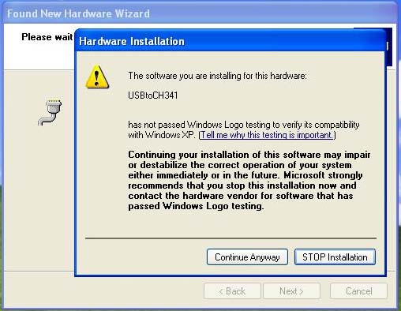

5. Click “Continue Anyway”, it will
not damage you computer. Then
please wait while the program is
being installed, and click “finish”
to completing the installation.

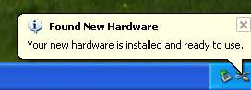
6. Now the USB cable is installed and ready
to use.

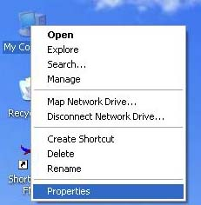
7. Target “My computer” , click the right button of the mouse.
then select “Properties” and click the left button.

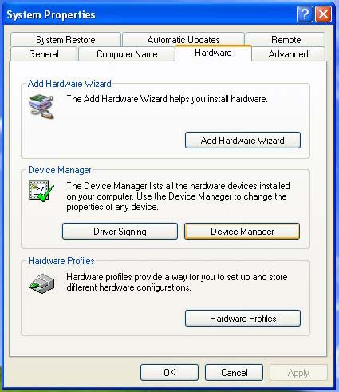
8. Choose “Hardware” , and click
“Device Manager”

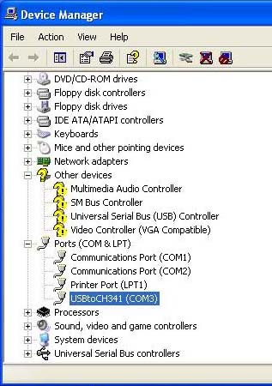
9. Click “Port (COM & LPT), and
remember the COM (COM3,or
COM4,depending on your computer)
right of the“USBtoCH341”,then exit.

10. Open the CD-Rom, copy
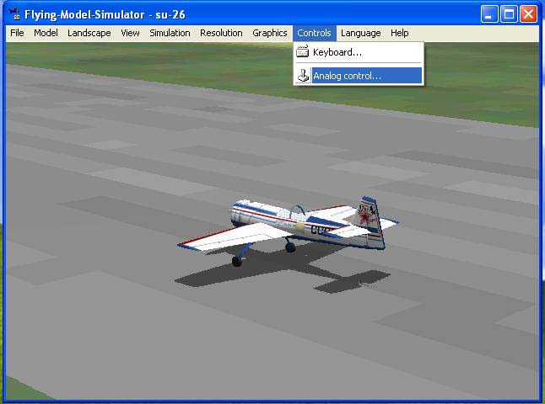
from the CD to your local
hard drive.(C:,D or others) and open it.Click 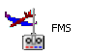 to run “FMS”, click
“Controls” and select “Analog control…”.

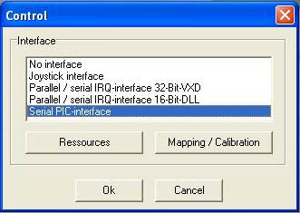
11. Choose the “Serial PIC interface”, then click
“Ressources”.

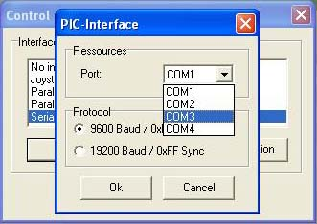
12. Set “Port” to “COM3 (the result of the step9)” ,
click “OK” .Then click “Mapping/Calibration”

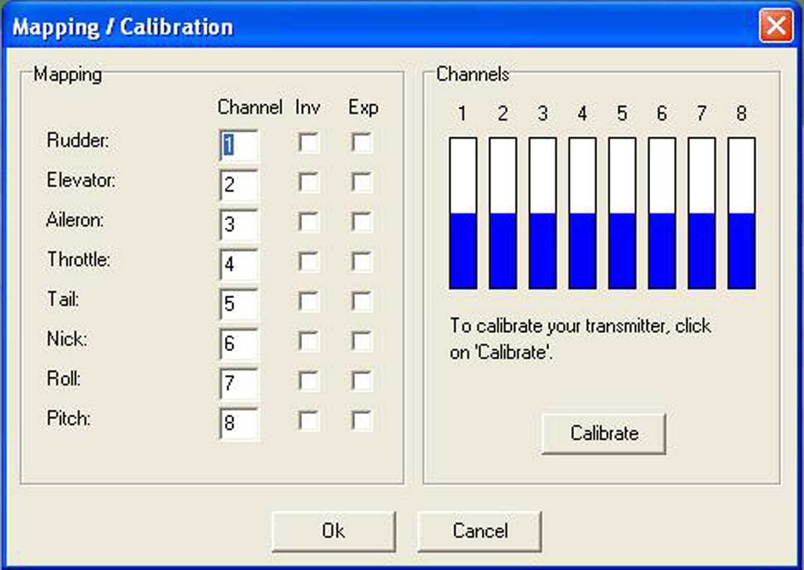
13. Click “Calibrate”

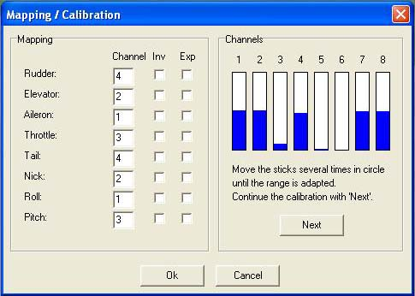
14. Move all joysticks to calibrate the radio.
Move aileron joystick to calibrate like the
channel 1,move elevator joystick to calibrate
like the channel 2,move throttle joystick to
calibrate like the channel 3,mov rudder
joystick to calibrate like the channel 4.
Setup the channels following the figure of the
right.(4,2,1,3,4,2,1,3).Then click “Next”.
Click “Finish” completing the calibration.
Notice :
The calibration is very important, it will
affect the performances of your model. About
the “channel”, there is a little different
setup on different window system.

15. Choose the plane which one you like ,and now,
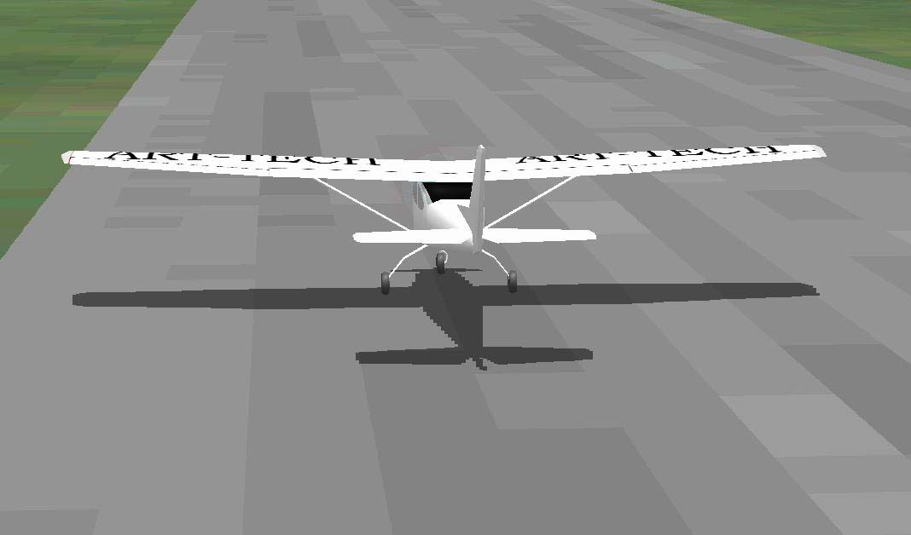
everything is ready, you can fly the model at any
moment you like.

16. Control keys:
I: Restart P: Pause Number 2,Number 3,Number 4,Number 5,Number 6,Number 8,Number 9: Change the view.
It is best to have the USB lead in the computer and your Transmitter and the Transmitter on before you load FMS.
If you don’t, the program may not recognize you Transmitter and you will have to proceed form point number 8 in
These instructions again. When you are finished, close the FMS program and then remove the USB lead. If it is not
Done in this order, it may generate an error message and automatically shut down the FMS program.

SEP / 2005
NOTICE: THERE IS A LITTLE DIFFERENT INSTALLING STEP ON DIFFERENT WINDOW SYSTEM

